TE 546 Computer Teaching Methods II



TUTORIAL

HOW TO DRAW A RECTANGLE

BY USING

GEOMETER’S SKETCHPAD PROGRAM

Prepared By

Elif ŞENGÜN

Bilkent University
Graduate School of Education
Computer and Instructional Teacher Education
November 2010

Introduction

In this tutorial, drawing a rectangle with Geometer’s Sketchpad program will be explained step by step.

In constructing our rectangle, we will learn the following:

- how to select, deselect, move and sizing the objects
- how to construct objects such as segments, perpendicular lines and parallel lines
- how to display the label of lines
- how to hide lines or objects
- how to create segments to merge the points as a line
- how to create new tool
- how to measure the lengths of lines and angles of the rectangle

HOW TO DRAW A RECTANGLE BY USING GEOMETER’S SKETCHPAD

- Open your Geometer’s Sketchpad program
- Open a new sketch from the File menu (Shortcut: Ctrl+N)

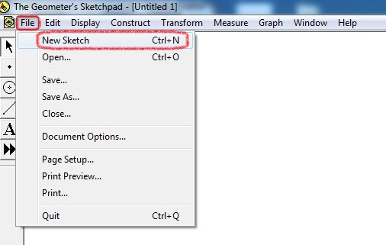

- Construct a line which covers two points (B and D). (You can select Straightedge Tool with pressing Shift to make a straight line for B and D points)

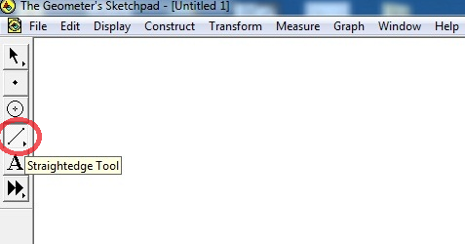

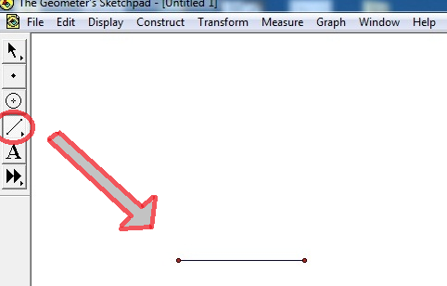

- Choose line and B, D points to make a perpendicular line for these points.

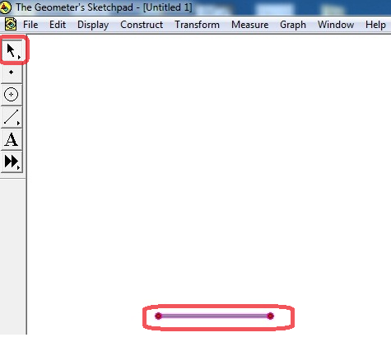

- Then, you can construct perpendicular lines from the Construct menu.

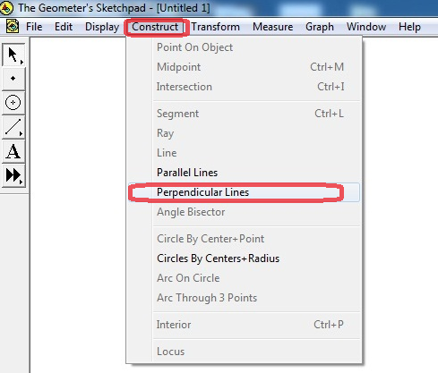

After that you can see perpendicular lines. It should look like the picture shown in below.

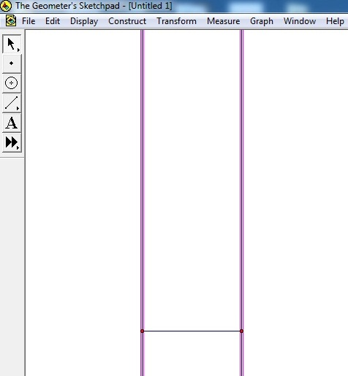

- Construct a point for A on the left line of the perpendicular line.

Firstly, you should select Point Tool, and then you should put a point on the left line of the perpendicular line.

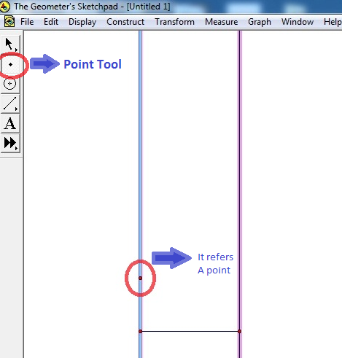

- Then, choose A points which is constructed previous step, and AB lines with left side of the perpendicular line to construct parallel lines.

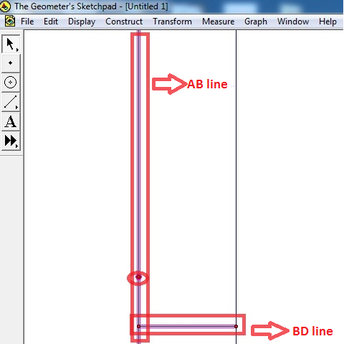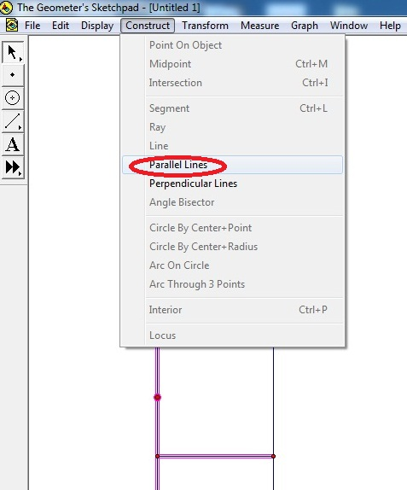

- Thus, you can see the parallel line as below:

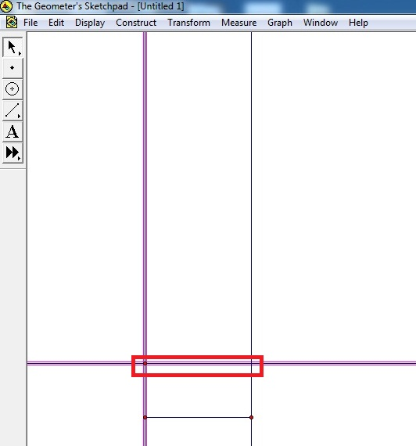

- After that, you can make a segment for C point by clicking the corner of right side of the parallel line.

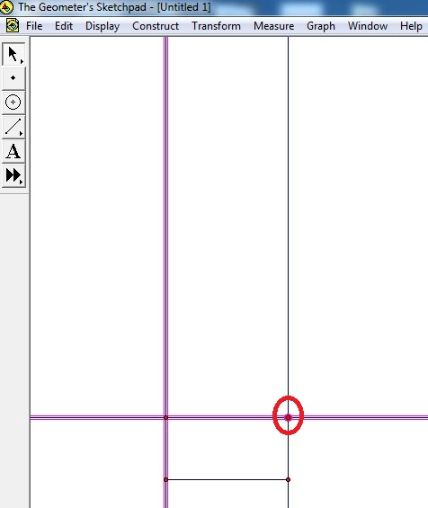

- Choose Hide Lines option from the Display menu.

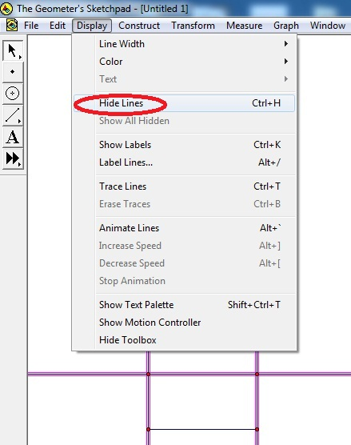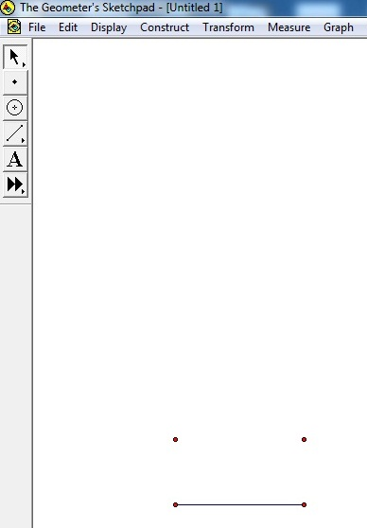

- Choose two points to merge them as a line, and then choose Segment option from the Construct menu. You can use same step to merge other points.

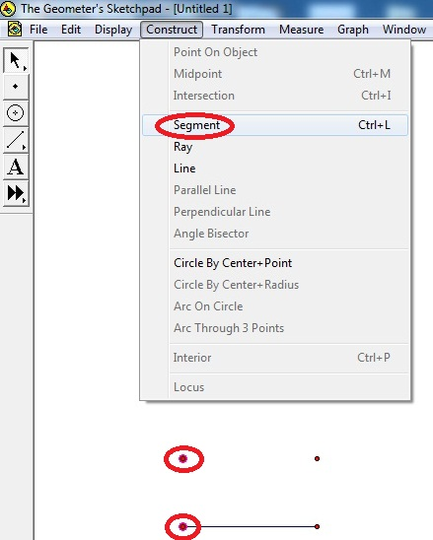

- Select whole parts of rectangle by using selection tool. Then you can click create a new tool option from the left side of the page. After that, you can write tool name which is created by user.

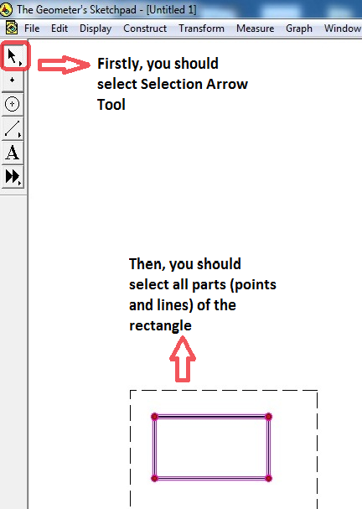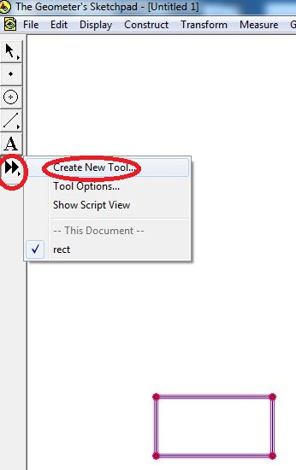

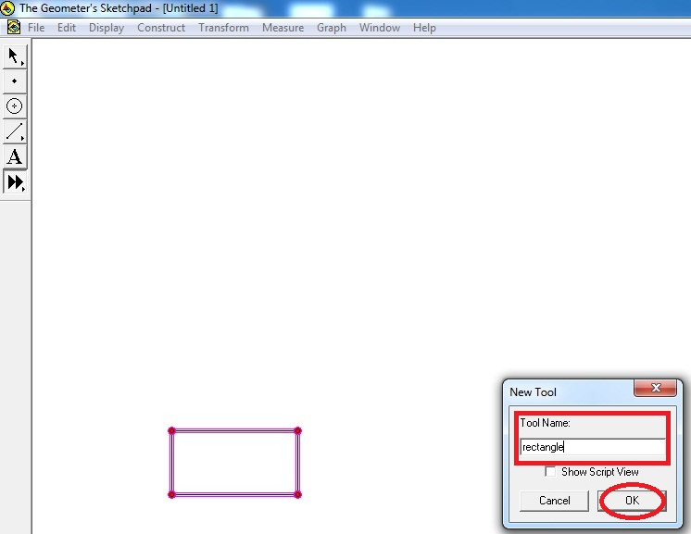

Note: Thus, you can use this tool (rectangle), which is created by you. It can be useful to make more copy of your rectangle, when you need to draw it.
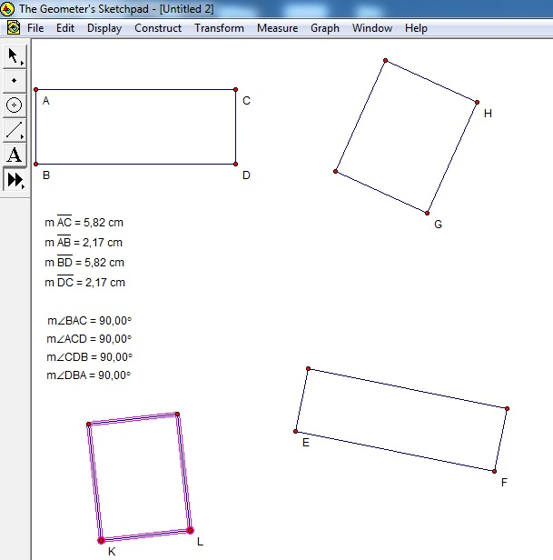

- Also, you can add label names for your rectangle by using Display menu.

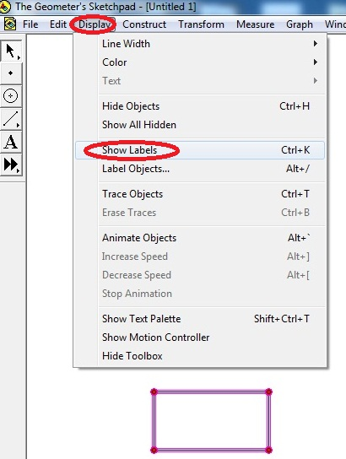

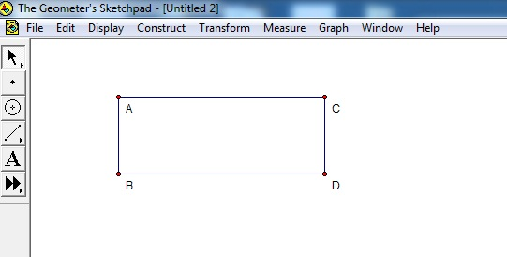

- After showing the labels, you can measure the lengths of lines. To measure the lengths of lines, you should select two points and line that you want to measure.

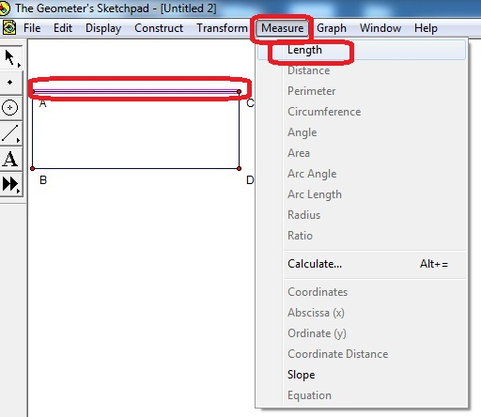

  - (You can use this step to measure other lines of the rectangle)

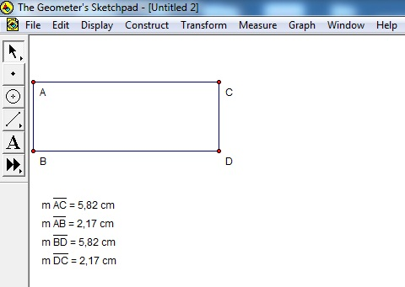

- Besides, you can measure the angles of the rectangle by selecting three point of rectangle which is covers the vertices.
Choose the three vertices points of the rectangle and then choose Measure menu and then click to Angle option.

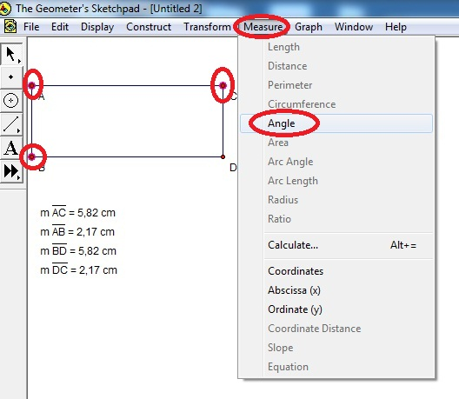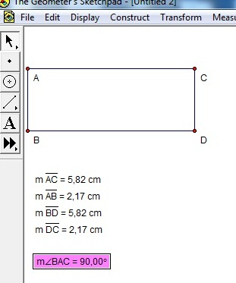

  - You can use this step to measure all vertices of the rectangle.



